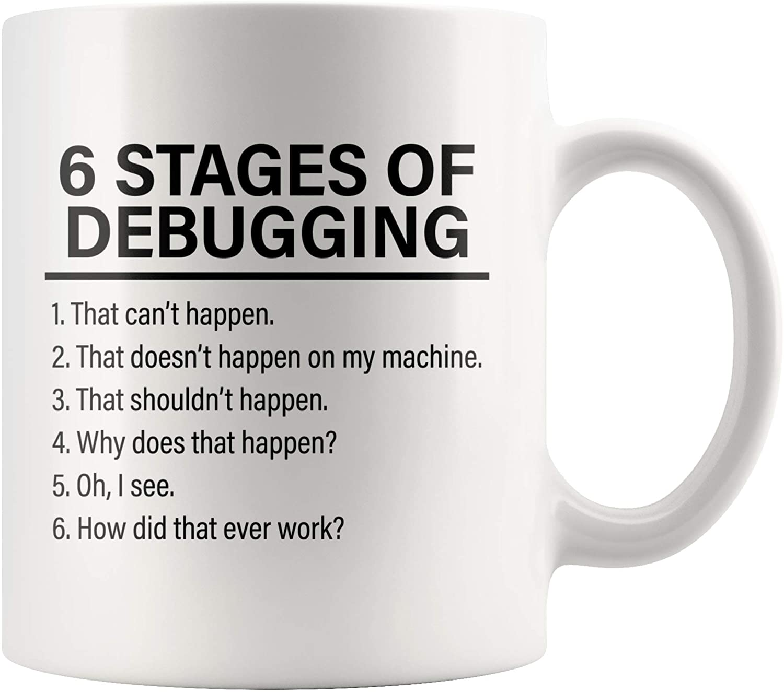  
  
Welcome to this debugging Python assignment! In this assignment, you will be presented with Python programs containing errors, and your task is to identify and fix these errors so that the programs work correctly.

Debugging is an important skill for any programmer, as even small errors can cause a program to behave unexpectedly or not work at all. By practicing debugging, you will not only learn how to fix specific errors, but also develop your problem-solving skills and gain a better understanding of how Python programs work.

Each program in this assignment contains several errors, such as syntax errors, logic errors, or runtime errors. Your task is to carefully analyze the code and identify the errors, then make the necessary corrections to ensure that the program works as intended.

Remember to test your code after making changes to ensure that it works correctly. Good luck, and have fun debugging!

# Challenge #1

* Open the file age.py
* This program prompts the user to entire their age and print out a message based on their age
* Identify any syntax, runtime and/or logic errors until the program actually runs.

|  |  |  |
| --- | --- | --- |
| Line with error | Error Type | How to fix |
| 1 | SyntaxError | Add colon to end of line |
| 14 | Runtime Error | Add positional arg to function call |
| 2 | Runtime error | Make age an integer |
| 4 | Runtime Error | Change “aged” to “age” |
| 6 | Logic Error | Make age_message return a str if age is greater than 65 |
|  |  |  |

# Challenge #2

* Open the file palindrome.py
* This program checks whether a given string is a palindrome or no
* Identify any syntax, runtime and/or logic errors until the program actually runs.

|  |  |  |
| --- | --- | --- |
| Line with error | Error Type | How to fix |
| 11 | Runtime Error | Remove “int()” infront of input |
| 10 | Runtime Error | Return the variable “string” |
| 5 | Logic Error | Subtract 1 from length-i |
|  |  |  |
|  |  |  |
|  |  |  |

# Challenge #3

* Open the file sum.py
* This program asks the user to enter a series of integers and calculates the sum of the even numbers.
* Identify any syntax, runtime and/or logic errors until the program actually runs.

|  |  |  |
| --- | --- | --- |
| Line with error | Error Type | How to fix |
| 7 | Logic Error | Change number % 3 to number % 2 |
| 8 | Logic Error | Add number to sum not subtract |
| 2 | Runtime Error | Sum should be 0 at start |
| 1 | Runtime Error | Return the sum from sum_even_numbers |
|  |  |  |
|  |  |  |